BM64 I2S/SPK out Configuration
Aux-in/MIC in can be configured in BM64 in 4 possible combinations
- Analog in and Analog out
Please choose the following in UI tool
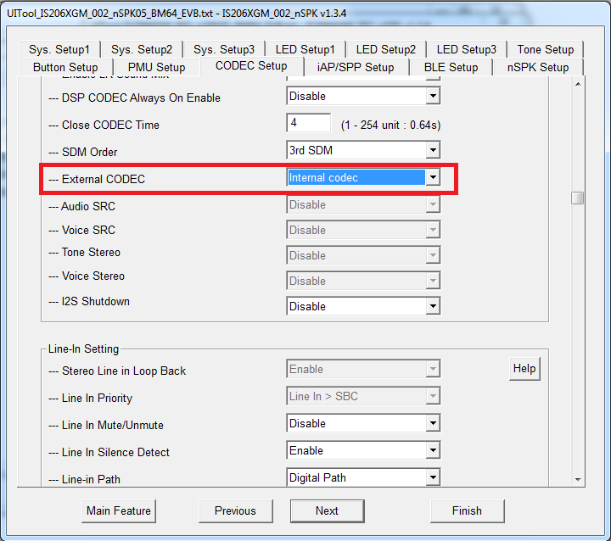

And following in DSP tool
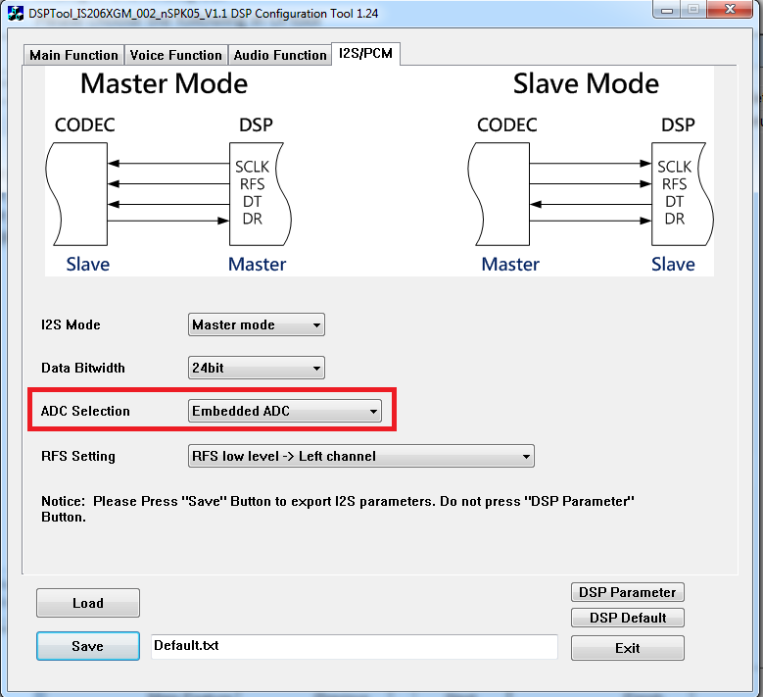

- Analog in and I2S out
Please choose following in UI tool
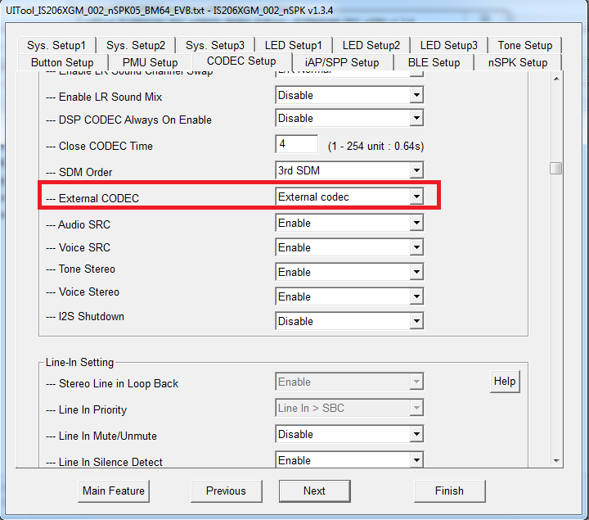

And following in DSP Tool

- I2S in and I2S out
Please choose the following in UI tool

And choose following in DSP Tool
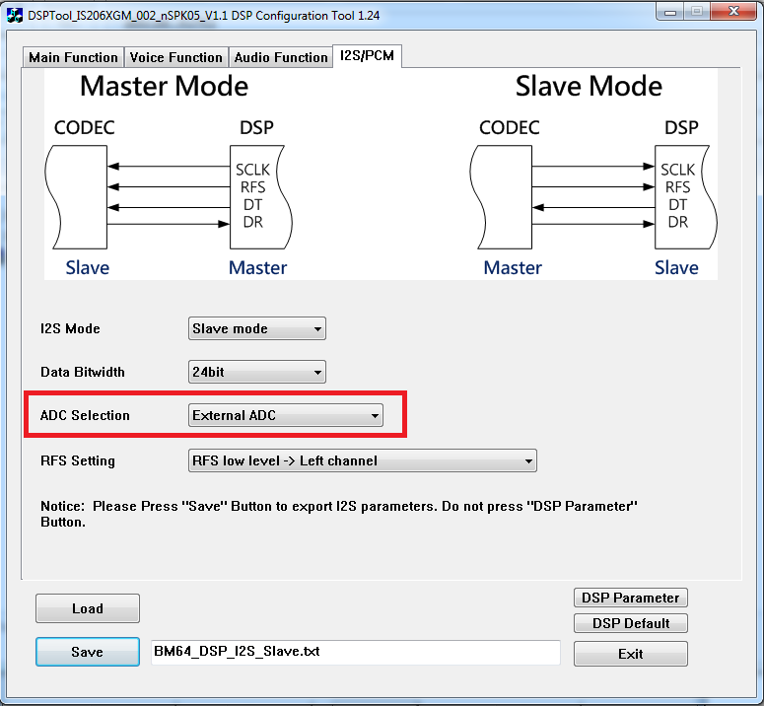

- I2S in and Analog out
For this configuration choose the following in the UI tool

And chose the following in DSP Tool
Create *.ipf file and program it into BM64. Since this configuration is not supported in UI/DSP tools, hence the following changes needs to be made in EEPROM location
0x1FC = 0x4A
0x344 = 0x0
0xAA0 = 0x3
0xAB4 = 0x3
Note 1: These address is specific to MSPK EEPROM table. DSPK will have different address.
Note2: When I2S_in is selected then it is advisable to use I2S slave mode.

Testing
First two configurations can be tested easily using one BM64 EVB.
- Please program attached MCHP_Multi_Analog1.ipf for testing Analog-in/Analog-out configuration

- Please Program EEPROM with MCHP_MULTI_03.ipf for Analog-in/I2S-out configuration.

- For testing I2S-in/I2S-Out configuration, two BM64 EVB is needed. Program Board 1 with MCHP_Multi_03.ipf. Program with Board 2 with MCHP_Multi_I2Sin_I2Sout.ipf

Make the following connections between Jumper J6 of Board 1 and Board 2

BOARD 1 BOARD 2
RFSO(3)-------------------RFSO(3)
SCLK0(7)------------------SCLK0(7)
GND(5)--------------------GND(5)
DT0(9)---------------------DR0(1)
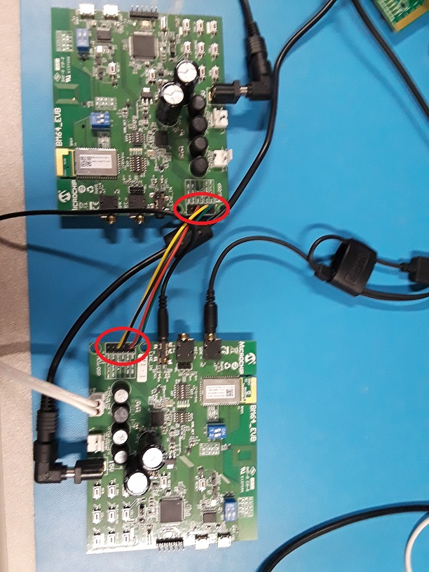
Pair and connect Board with a cell phone and play music. Power on board 2 and connect a speaker with R+/R-. Also insert a cable in line-in. This is to enable line-in detect code in MCU.
Music will be heard on connected speaker of Board 2.
- For testing I2S-in/Analog-Out configuration, two BM64 EVB is needed. Program Board 1 with MCHP_Multi_03.ipf. Program with Board 2 with MCHP_Multi_I2Sin_Analogout.ipf. Make the following changes in EEPROM of the board 2 using MicrochipBTUtil.7Z.


0x1FC = 0x4A
0x344 = 0x0
0xAA0 = 0x3
0xAB4 = 0x3

Make the following connections between Jumper J6 of Board 1 and Board 2

BOARD 1 BOARD 2
RFSO(3)-------------------RFSO(3)
SCLK0(7)------------------SCLK0(7)
GND(5)--------------------GND(5)
DT0(9)---------------------DR0(1)
Pair and connect Board with a cell phone and play music. Power on board 2 and connect a speaker with SPK. Also insert a cable in line-in. This is to enable line-in detect code in MCU.
Music will be heard on connected speaker of Board 2.

